Experiment No. 9

Name : Rinoy Kuriyakose
Roll No: 56
Aim:

Familiarization of various system calls in UNIX operating system

(a) Program to accept the limiting value ‘n’as input and generate the Fibonacci sequence of n numbers using the child process while the parent process generate the first n prime number
(b) Generate an N level hierarchy of processes and also display the parent id of process.
(c) 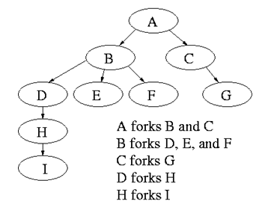

Program (a)
#include<stdio.h>
#include<unistd.h>
#include<sys/wait.h>
void fibonacci(int n){
int a =0 ,b = 1,c,i;
printf(" %d %d ",a,b);
c=a+b;
while(a+b<=n) {
c = a + b;
printf(" %d ",c);
a = b;
b = c;
}
}
void prime(int n){
int i,j,flag;
for (i=2; i<=n; i++){
flag=1;
for (j=2; j<=i/2; j++){
if(i%j == 0){
flag=0;
break;
}
}
if(flag==1){
printf(" %d ",i);
}
}
}
int main(){
int n;
printf("\n\nEnter the value of n :");
scanf("%d",&n);
if(fork() ==0 ){
printf("\n\nChild Process : Fibonacci Series \n");
fibonacci(n);
}else{
wait(NULL);
printf("\n\nParent Process : Prime Numbers \n");
prime(n);
}
printf("\n");
}

Output:
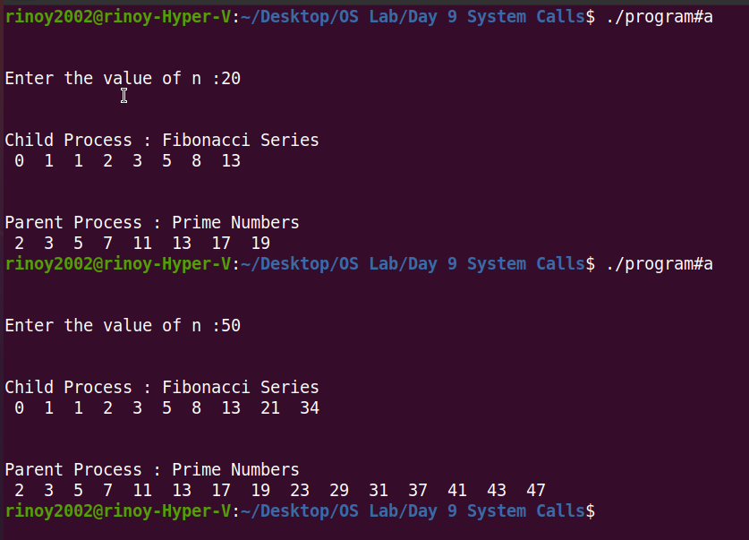

Program (b)

#include<stdio.h>
#include<unistd.h>
#include<sys/wait.h>
void main(){
int n,i;
printf("Enter the value of N : ");
scanf("%d",&n);
for(i =0; i<n ; i++){
if(fork() == 0){
printf("Level %d: Child pid: %d Parent pid: %d \n",i,getpid(),getppid());
}else{
wait(NULL);
break;
}
}
}
Output:
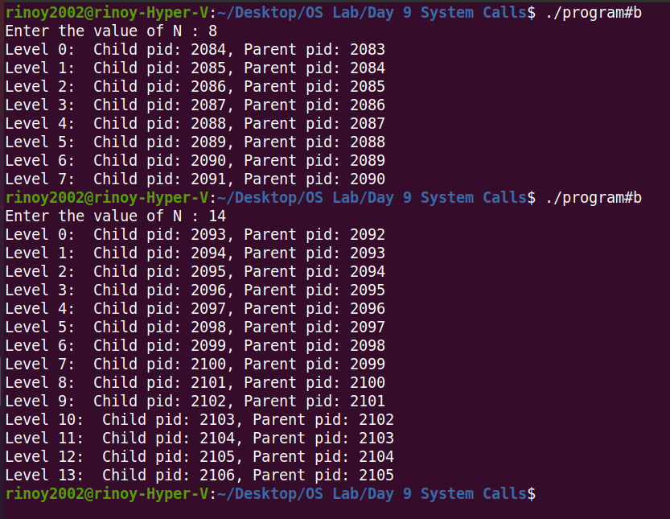

Program(c)

#include <stdio.h>
#include <unistd.h>
#include <sys/wait.h>
void main() {
printf("Parent A: %d\n", getpid());
if (fork() == 0) {
printf(" Child B: %d forked by Parent A: %d\n", getpid(), getppid());
if (fork() == 0) {
printf(" Child D: %d forked by Parent B: %d\n", getpid(), getppid());
if (fork() == 0) {
printf(" Child H: %d forked by Parent D: %d\n", getpid(), getppid());
if (fork() == 0) {
printf(" Child I: %d forked by Parent H: %d\n", getpid(), getppid());
}else{
wait(NULL);
}
}else{
wait(NULL);
}
}else if (fork() == 0) {
printf(" Child E: %d forked by Parent B: %d\n", getpid(), getppid());
}else if (fork() == 0) {
printf(" Child F: %d forked by Parent B: %d\n", getpid(), getppid());
}else{
wait(NULL);
}
}else if (fork() == 0) {
printf(" Child C: %d forked by Parent A: %d\n", getpid(), getppid());
if (fork() == 0) {
printf(" Child G: %d forked by Parent C: %d\n", getpid(), getppid());
}else{
wait(NULL);
}
}else{
wait(NULL);
}
}
Output:

